School Health Council
Meeting Agenda

Thursday March 26, 2015
Savage Educational Center
Room 219
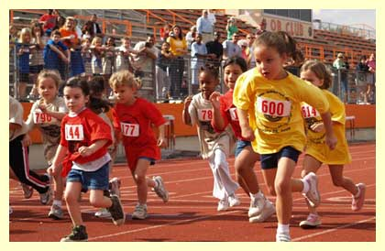
3:30pm

Welcome:

Spring Track Night – Friday May 8th
From 5-6:30pm

Funding- AFHK has just posted grant opportunities, and I am looking into the possibility of applying

Partners - Marathon Physical Therapy and Sports Medicine has offered to sponsor our water bottles and string bags. They are providing 100 of each, and we should have them by May 1st

Tara has pinny numbers, but we need one more box of safety pins
Events –

Help from Track Team-

All outdoor event

No rain date

Lets plan an awesome event!

Website –http://www.norwood.k12.ma.us/about/Wellness.cfm
Anyone have pictures from Wellness Week? Or any activities going on in the schools?

Next Meeting is April 30th 3:30pm – Savage Center Room 219

Thank you all for your continued support to the School Health Council.

