School Health Council
Meeting Agenda

Thursday March 26, 2015
Savage Educational Center
Room 219
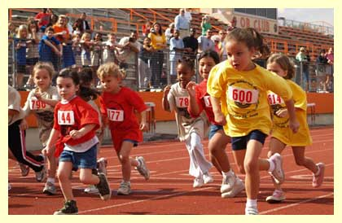
3:30pm

Welcome:

Spring Track Night – Friday May 8th
From 5-6:30pm

Funding- AFHK has just posted grant opportunities, and I am looking into the possibility of applying, anyone else?

Partners - Marathon Physical Therapy and Sports Medicine has offered to sponsor our water bottles and string bags. They are providing 100 of each, and we should have them by May 1st

Tara has pinny numbers, but we need one more box of safety pins

Hospital will donate 8 oz water bottles for each participant, Thanks Linda!
Events Promotion – Brianne has it posted on the website- Thank you
Info in schools?
Any other promotion ideas?

Sign ups – Brianne has the sign-ups ready for Google Docs
Can we get it linked to each elementary website?

All outdoor event

No rain date

Lets plan an awesome event!

Website –http://www.norwood.k12.ma.us/about/Wellness.cfm
Anyone have pictures from Wellness Week? Or any activities going on in the schools?

Next Meeting is April 30th 3:30pm – Savage Center Room 219

Thank you all for your continued support to the School Health Council.

