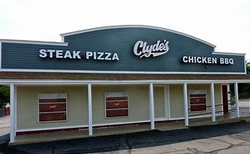

Dining Out for a Cause at Clyde’s
Thursday June 14th, 5-9 pm

Clyde’s will be generously donating 15%
of dine in and take out (order online or call 508-660-2206)
food and drink (non-alcoholic) purchases
to the Oldham Elementary PTO, just give them this flyer!

Clyde’s is located at 642 Providence Highway (Rte 1) in Walpole.

