WHAT TO PACK

Clothing and Accessories
- Comfortable walking shoes; TWO pairs of SNEAKERS are highly recommend!!
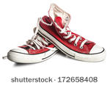
- Shirts (short and long sleeved)
- Socks and underwear
- Watch and sunglasses (optional)
- Pants/shorts/jeans- weather and dress-code appropriate
- Pajamas
- Raincoat and/or umbrella
- Lightweight nylon jacket or fleece (rather than bulky sweatshirts)
- “Dressy Casual” for Dance (sundress, skirt, polo shirt, not a semi-formal)
Dress should be appropriate for walking and touring the outlined locations. Students are required to dress comfortable and presentable. Students also need to be prepared for inclement weather.
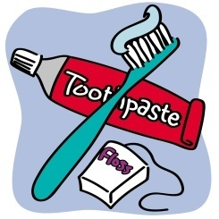
Toiletries
- Toothbrush and toothpaste
- Shampoo/conditioner and soap
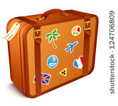
- Deodorant!!!
- Hairbrush/comb
- Sunscreen
- Any medications (as stated in medical forms) or health products
- Spare set of contact lenses/glasses (if applicable)
Can coordinate any shared accessories with roommates.

Money and Electronics
- Cash: recommended $20-$30 per day for snacks and souvenirs (Breakfast, lunch and dinner are provided)
- Pouch or wallet to safely store money (students are responsible for their own money)
- Reusable water bottle is highly recommended
- Cameras, phones, chargers, emergency chargers, and headphones (internet will NOT be consistently available)

Luggage
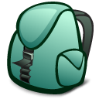
- ONE suitcase for clothes and toiletries that is stored under the bus. (Not accessible during daily driving and travel.)
- EF Tours Backpack for the bus and some locations.
- Small bag or string bag are encouraged for touring some locations.

Students should pack one piece of luggage and then use their EF Tours Back Pack to store any items they would like to carry on the bus, including a smaller bag/string bag.

SNACKS for the Bus
NO PEANUT PRODUCTS!
*Specific allergies or food alternatives should be identified on the medical forms and coordinated with the Trip Leader.

