Creating a table on Google Docs.
To add a table to a page, click on the Insert tab on the Word ribbon. From the Insert tab, locate the Tables panel, and the Table item:
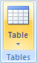
Click on Table to see the following menu:
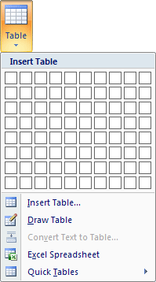
Move your mouse over the squares to select the number of columns and rows you would like in your table.
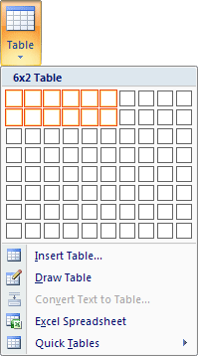
Pulse Activity Example
- Create 2x6 table
- Add headings as seen below.
Activity | Pulse Rate
Resting
Walking
Running
Resting 1 min
Resting 3 min

- Fill in your data.
- If time, change font, color etc.

Creating a bar graph on Goggle Sheets
- Open up a new spread sheet
- Add Headings to Columns A1 and B1 as seen below
Activity | Pulse Rate
Resting
Walking
Running
Rest 1 min
Rest 3 min

- Fill in your data.
- Select/Highlight your data.
- Go to Insert, then chart.
- Choose appropriate bar graph.
- You should see a graph like this:
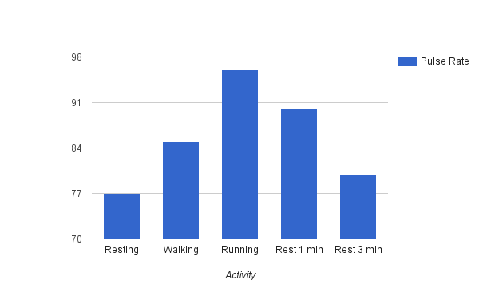

- To label your chart right click on the chart.

- Click and add title “How activity affects pulse”

- Right click on chart again. Select axis. Add left vertical axis title “Pulse Rate”.

- Click insert. Chart should look like this:

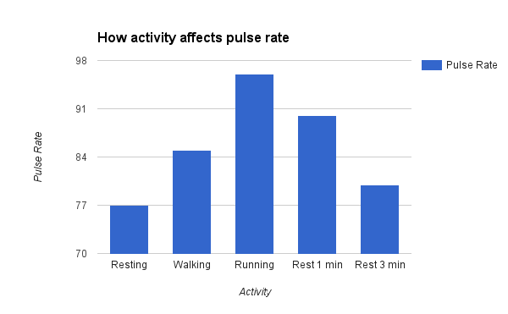

- On the top right of graph, click the drop down arrow and select “copy graph”.

- Open your lab document and paste.

