Welcome to the

Willett Preschool

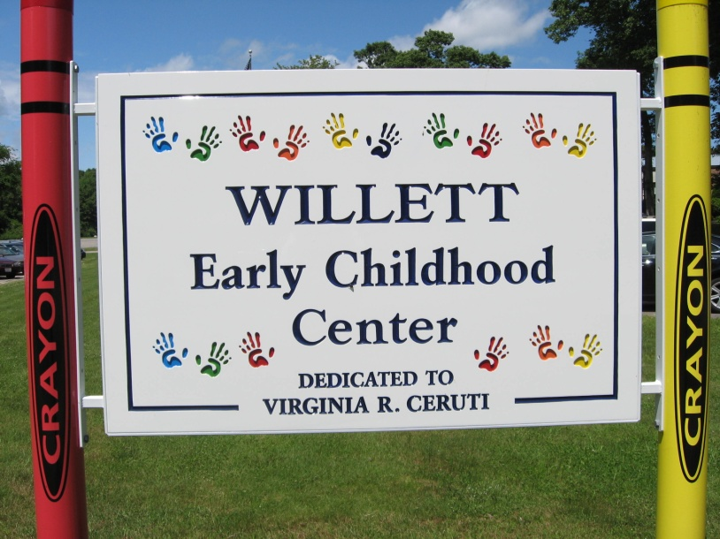

Room A-7

I am excited for you to join our classroom at the Willett School!

Here is a picture of me, Ms. Lauren:

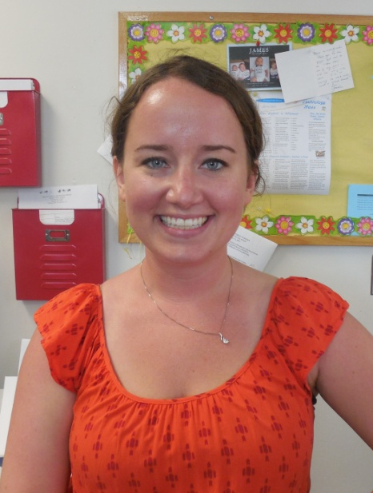

We also have two other teachers in our classroom.

Here is a picture of Ms. Judi:

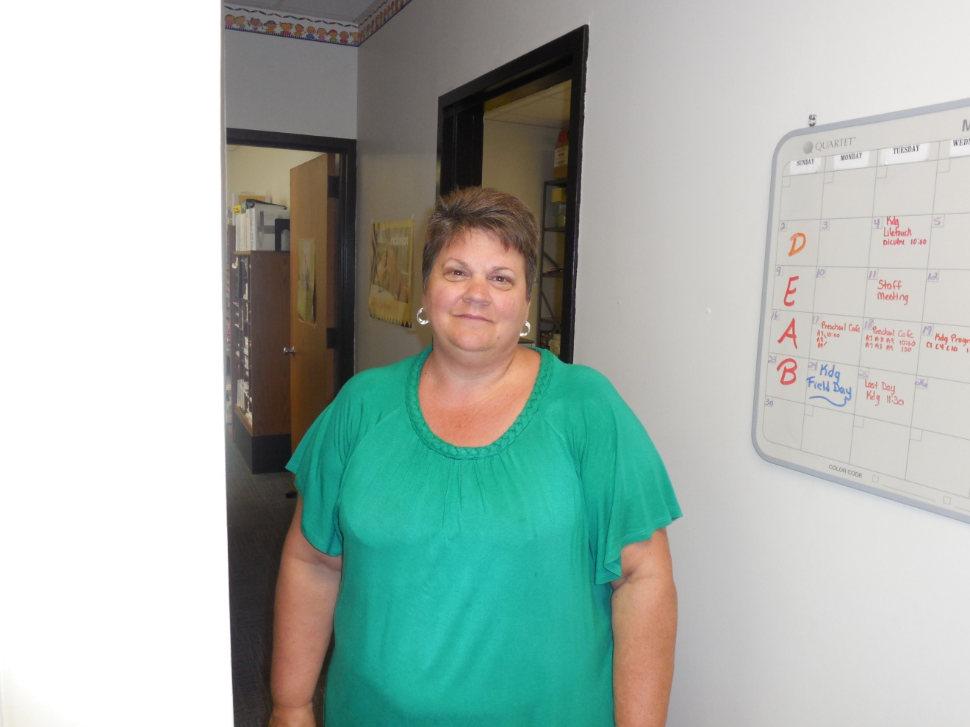

And here is a picture of Ms. Kim:

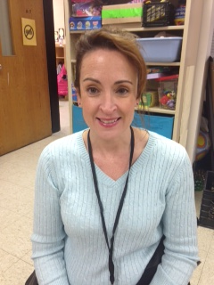

When I come to school, I will ride the bus or my grown up will drop me off at Door #3.

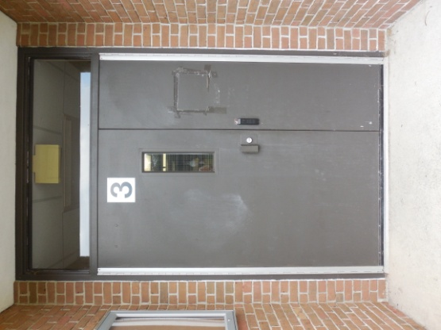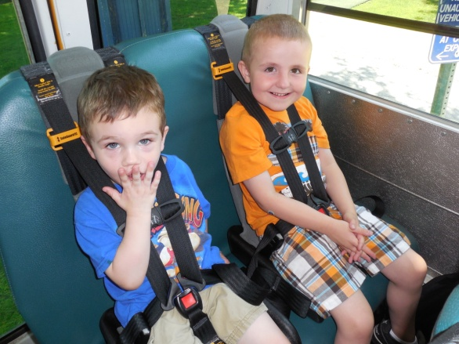

Riding the bus to school is fun!

Here is a picture of our cubbies. Every morning when you come in to school you will hang up your coat and backpack here. One of your teachers can help you if it’s tricky! After we hang up our coats, we go right into the classroom and wash our hands before we begin playing with all the fun toys!

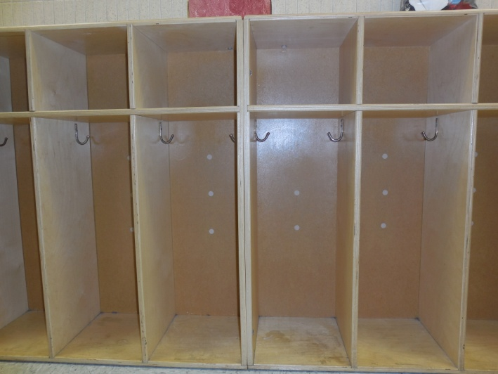

Here are some pictures of your new classroom:

The kitchen area is fun to play restaurant, dress up, doctor’s office, animal hospital, and other fun pretend play activities ☺

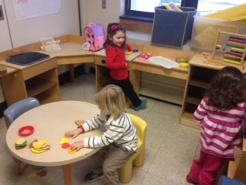

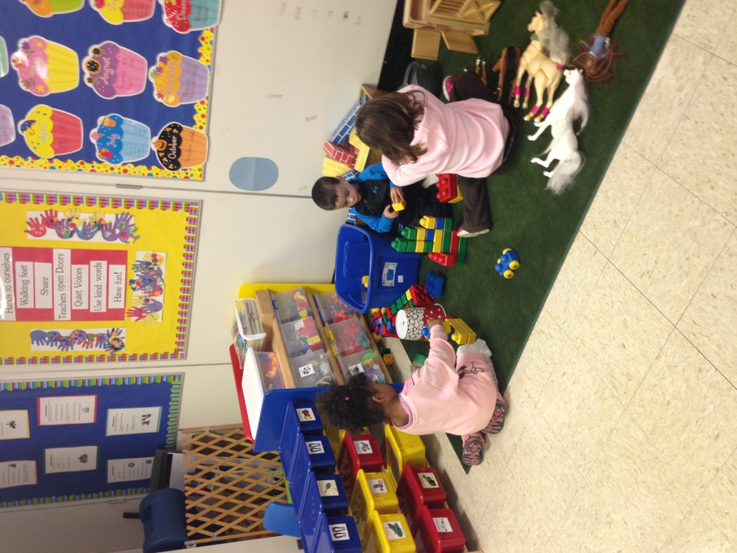

The green rug area has blocks, trucks, cars and garages, farm and farm animals, and more fun toys to play with!

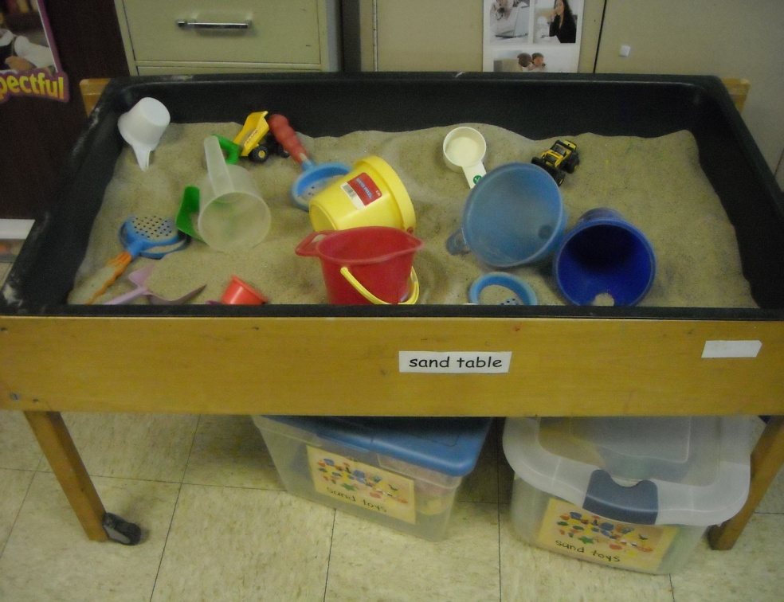

During free play, we usually have the sand table open. Some days we have the water table open. It is filled with boats, funnels, and other cool things to play with!

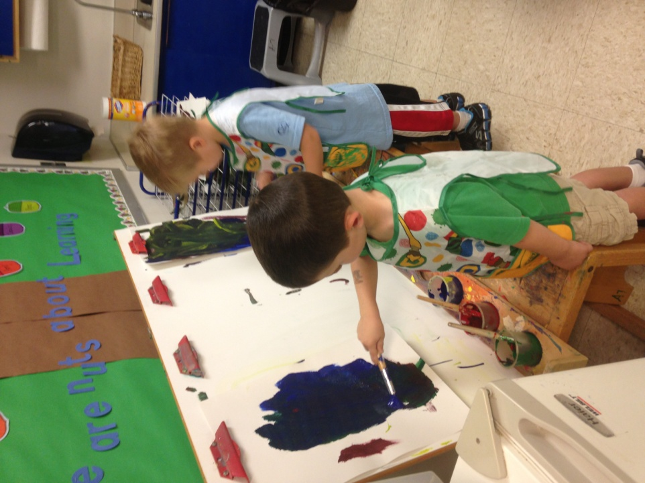

The boys and girls love to paint pictures to bring home for their families!

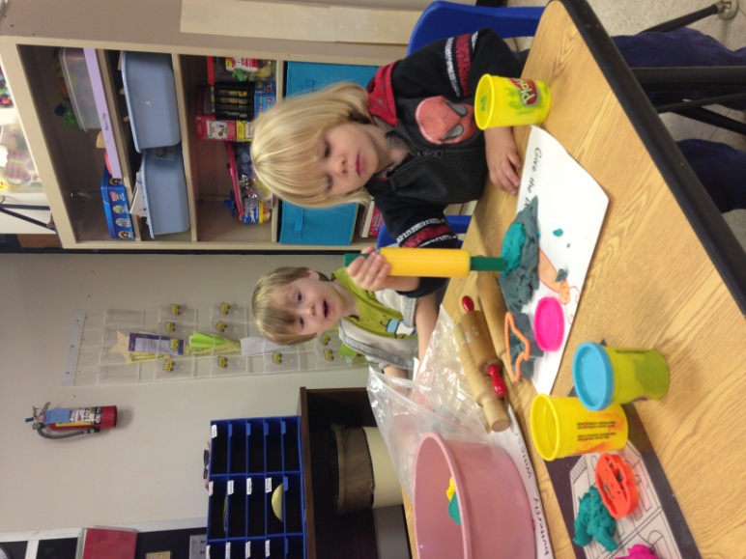

Play dough fun!

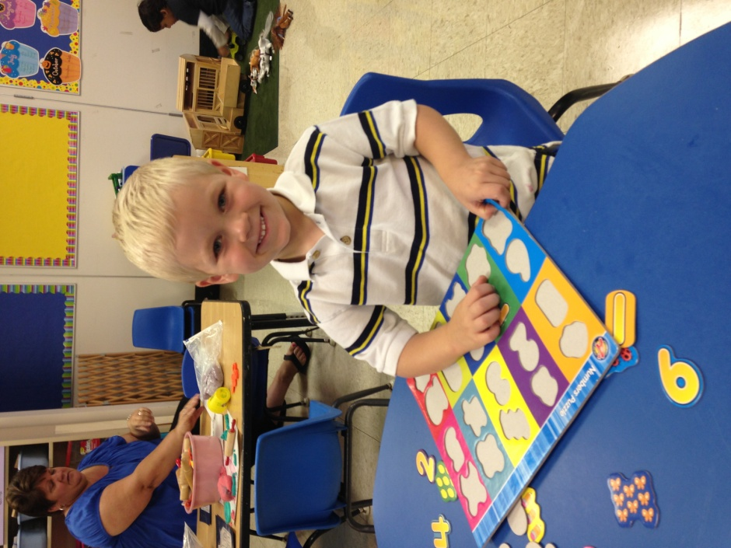

Puzzles

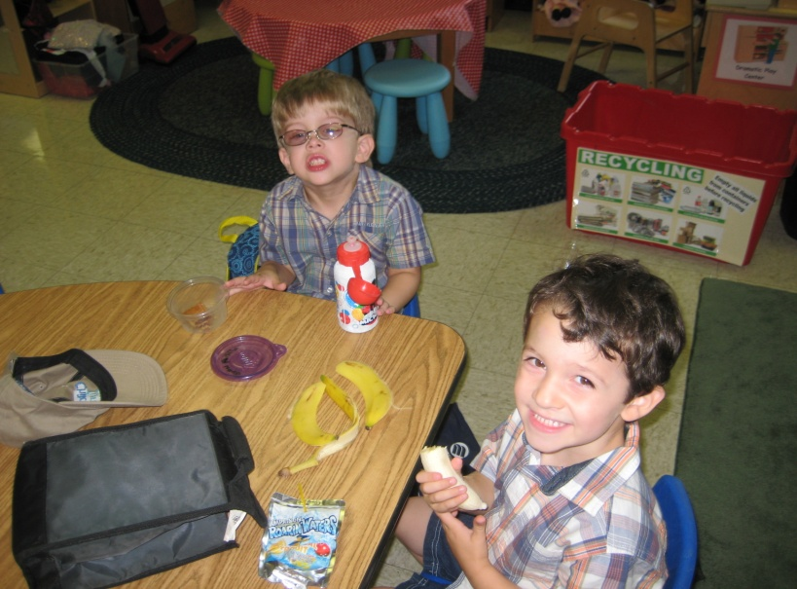

Snack time!

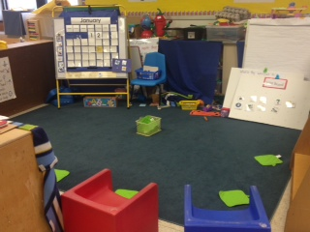

This is our blue rug. We meet here every morning after free play for Circle Time. Everyone gets a green spot to sit on! We also meet here to read stories and sing songs!

We take turns having classroom jobs. The children love it when it is their turn for a job! I wonder which job you will like the best? Our jobs are door holder, line leader, flag holder, weather person, DJ, table washer, caboose, and calendar helper!

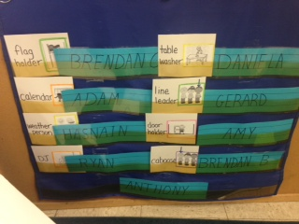

This is Michelle. She may take me to the speech room or play with me and some friends in my classroom.

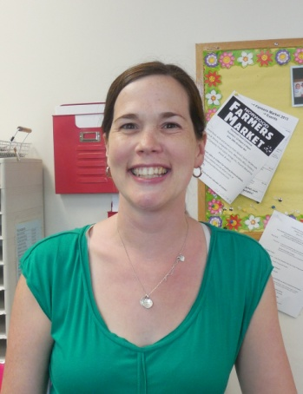 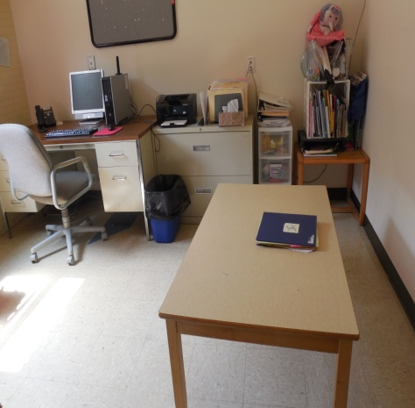

Miss Michelle Speech room

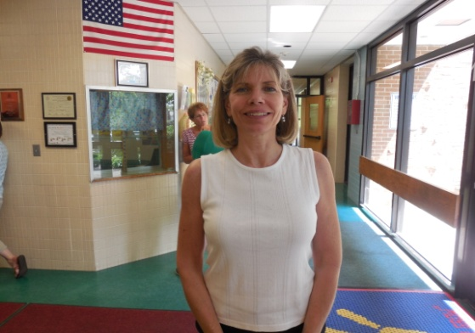 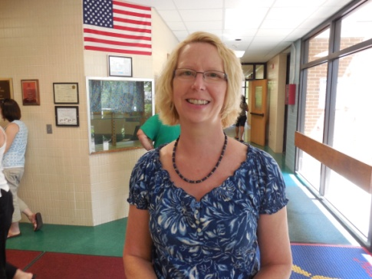

Miss Seanna (PT) Miss Priscilla (OT)

Here are some pictures of the Motor Room! It is a fun room you will visit with Miss Priscilla and Miss Seanna to exercise your muscles.

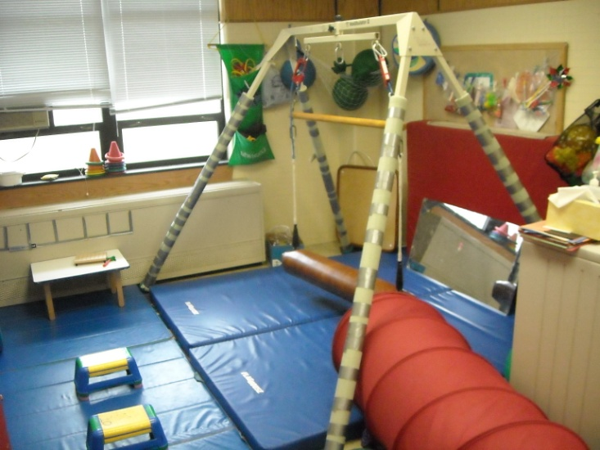 *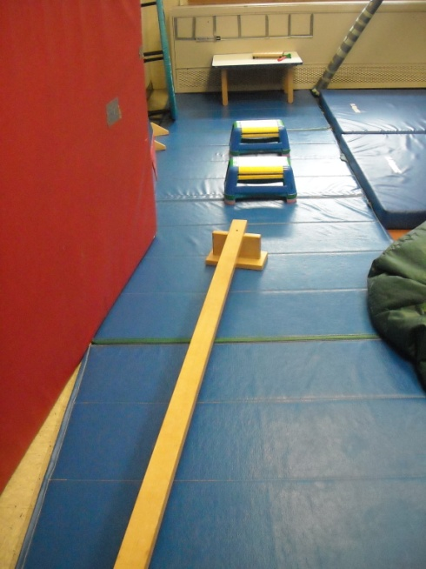*

We also go to the playground when it is not raining outside!

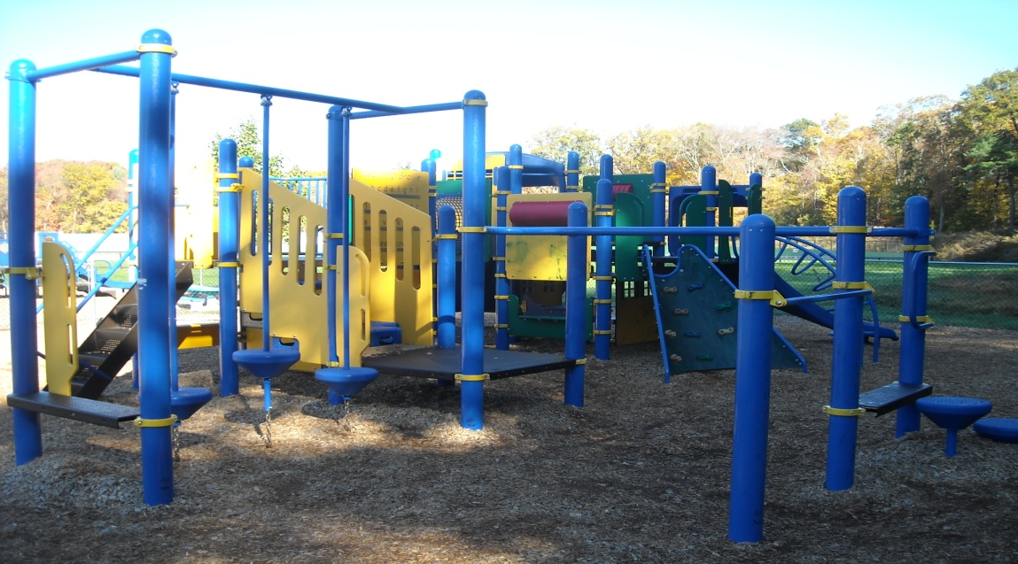

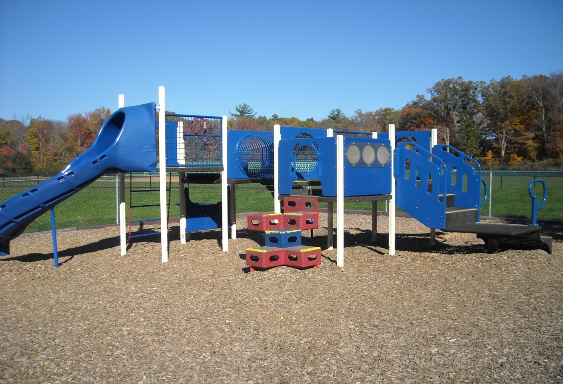

*We think you are going to love the Willett Preschool!*