Pregunta | Compañero 1 | Compañero 2
¿How do you colaborate in your community?
¿How can you do to solicit the help of other people?
¿Do you like to help (support) others? ¿Why or why not?
¿What volunteer groups are you familiar with? ¿What do they do?
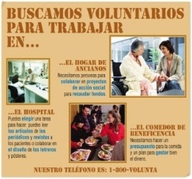
¿What types of events do volunteers organize? ¿Which are the best?
¿What means of communication are useful for campaigns? ¿Why?
¿What can you/could you be able to recycle and pick up in your community? ¿Where?
¿What is your favorite slogan/motto?
"I'm loving it!"
¿What is your favorite logo?

